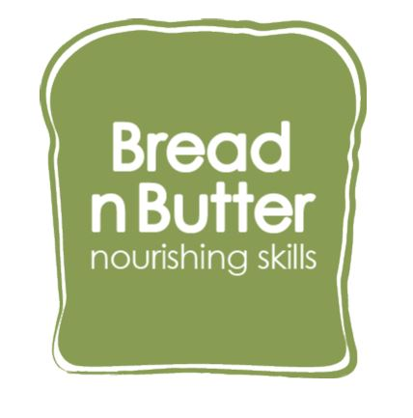**Job Opportunity with Bread n Butter**

**Job Title -** Cookery Assistant

**Location -** Enfield

**Report to** - One of the Bread n Butter Directors

**Bread n Butter CIC**

Bread n Butter is a North London based social enterprise

We are food educators teaching cookery life skills whilst addressing food waste and health and social inequalities. We believe everyone should have the confidence to be able to cook for themselves and the knowledge of how to eat healthy food affordably and sustainably. Our services include cookery classes, healthy eating workshops and food waste workshops in schools and in communities. We work with children, youths, adults and families. We also work with vulnerable adults and those with special needs.

We have secured funding and new opportunities so it is an exciting time to join our team. If you would like to work for a growing business please get in touch.

**Ideal Candidate**

* You are a foodie who is passionate about cooking from scratch and keen to pass skills on
* You are looking for part time work 4-8 hours a week
* You are available to start in September/October 2025
* You have a basic understanding of healthy eating and eating a balanced diet

**Job role**

We have an opportunity to assist in our community cooking classes across Enfield. You will be required to assist the cookery leader during the session. Your role is to help set up and tidy up and the start and end of the session. There will be a variety of dishes to prepare which will be shared out amongst the group. Attendees will also cook the food and tidy up as they go along. You will also be required to help participants as required during the class. We always cook with Halal meat and include vegetarian dishes. The cookery session lasts for 2 ¼ hours.

Attendees will be a mix of residents from the local area, most of which are vulnerable adults. There will be a maximum of 12 participants.

**Timings & Duration**

The classes occur during the day throughout the week. The cookery session lasts for just over 2 hours although you will be required to be there 15 minutes prior in order to set up and for 15 minutes afterwards to finish tidying up

**Person Specification**

**Skills**

* Able to communicate effectively and appropriately with people from a variety of backgrounds, cultures and abilities and have a good rapport with children
* Good at using your own initiative and can think on your feet
* Has the ability to work under pressure
* Be able to work under the guidance of a cookery leader

**Qualifications and Knowledge**

* Passion for healthy eating and home cooking
* Up to date Food Hygiene Certificate (we can arrange this if needed)
* Experience of working with children, young people or adults. Ideally experience of working with vulnerable adults

**Specifications**

* This role will require a satisfactory DBS check (we can arrange this if needed)
* This role is for a sub-contractor and the holder will be responsible for their own tax and NI payments
* Provide two recent references

**Salary**

* £15 per teaching hour